StorageDrives Blueprint Documentation

1-Folder Structure

Knowledge Base

What is Folder Structure
# Source: AI Source: Provided by: [Data Path: Persons Table -> ID Column: 1, Name_En Column: Motasem Essam] -> From: [ChatGPT] on [7/14/2025]
A Folder Structure is a ready-made structure you can create once and reuse whenever you want to keep your laptop organized. Instead of creating new folders randomly, you follow the same structure every time. Here’s an example template for your laptop:

What is file Structure
# Source: AI Source: Provided by: [Data Path: Persons Table -> ID Column: 1, Name_En Column: Motasem Essam] -> From: [ChatGPT] on [7/14/2025]
A Folder Structure File is a reference document that defines:
- The root folder
- All top-level folders
- Their purpose
- The rules for creating and maintaining folders
It acts as a single source of truth for how files must be organized.

Rules and Guidelines

1-Folders structure
# Source: AI Source: Provided by: [Data Path: Persons Table -> ID Column: 1, Name_En Column: Motasem Essam] -> From: [ChatGPT] on [7/14/2025]
Main → Central organization folder that contains all top-level categories.
Format (Required Structure)
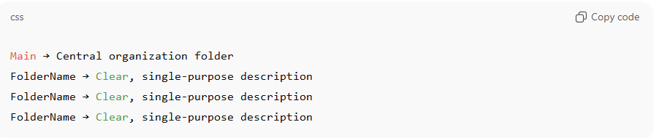
Rules
- Main is mandatory and represents the root of the system.
- Every folder under Main must follow the format:
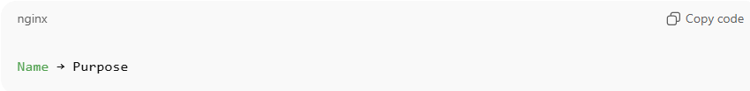
Name → Purpose

- Each folder must have one and only one clearly defined purpose.
- Folder names must be self-explanatory nouns.
- Descriptions must state what the folder contains, not how it is used.

Example (General Use)
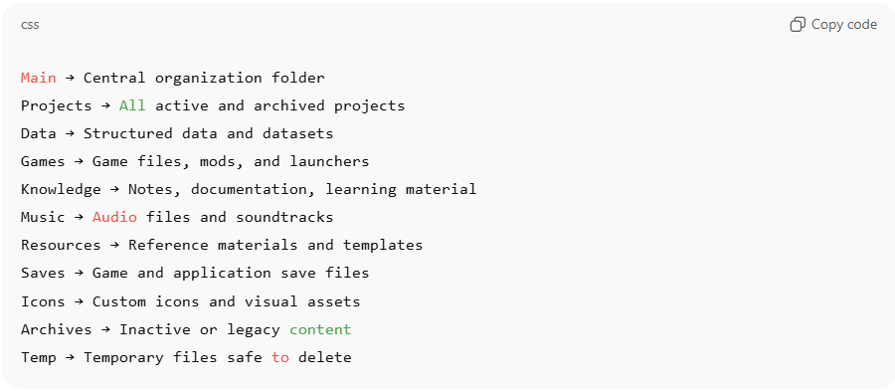
Main → Central organization folder
Projects → All active and archived projects
Data → Structured data and datasets
Games → Game files, mods, and launchers
Knowledge → Notes, documentation, learning material
Music → Audio files and soundtracks
Resources → Reference materials and templates
Saves → Game and application save files
Icons → Custom icons and visual assets
Archives → Inactive or legacy content
Temp → Temporary files safe to delete

2-Adaptive Numbering for Files
# Source: AI Source: Provided by: [Data Path: Persons Table -> ID Column: 1, Name_En Column: Motasem Essam] -> From: [ChatGPT] on [7/14/2025]
Rule 1: Add Number Prefix
- Add a numeric prefix at the start of each file name to indicate its order.
Rule 2: Determine Digit Length
- The number of digits in the prefix depends on the total number of files:
  - 1–9 files → 1- to 9-
  - 10–99 files → 01- to 99-
  - 100–999 files → 001- to 999-
  - 1000–9999 files → 0001- to 9999-
Rule 3: Maintain File Name and Extension
- Do not alter the rest of the file name or the extension (.pdf, .docx, .mp4, etc.).
- Exception: use conversion tools if changing file format is required (e.g., .mp4 → .mkv, .docx → .pdf).
Examples:
- 7 files → 1-File.pdf, 2-File.pdf … 7-File.pdf
- 12 files → 01-File.pdf, 02-File.pdf … 12-File.pdf
- 145 files → 001-File.pdf … 145-File.pdf

2-File/Folder reference

Knowledge Base

What Are File/Folder Paths?
# Source: AI Source: Provided by: [Data Path: Persons Table -> ID Column: 1, Name_En Column: Motasem Essam] -> From: [ChatGPT] on [7/14/2025]
A file or folder reference identifies the exact location of a file or folder within a computer’s storage system using its path. Like a home address, the path clearly shows where the computer—and the user—can find and access the file or folder.

Rules and Guidelines

1-File/Folder Paths
# Source: AI Source: Provided by: [Data Path: Persons Table -> ID Column: 1, Name_En Column: Motasem Essam] -> From: [ChatGPT] on [7/14/2025]
- Every folder or file path Starts with Path:
- There are five types of paths have rules describe the location of any folder or file in a flexible and standardized way.

1. Absolute Path (Exact Location)
# Source: AI Source: Provided by: [Data Path: Persons Table -> ID Column: 1, Name_En Column: Motasem Essam] -> From: [ChatGPT] on [7/14/2025]
- Description:
The full, direct address from the drive root to the target folder.
This gives the exact location with no ambiguity.
- Format:
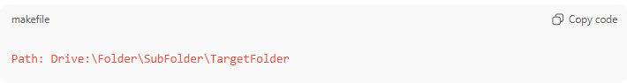
Path: Drive:\Folder\SubFolder\TargetFolder
- Example:
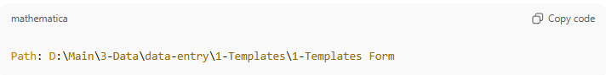
Path: D:\Main\3-Data\data-entry\1-Templates\1-Templates Form
(Means: the folder 1-Templates Form is exactly in this path.)

2. Relative Path (Backward Reference)
# Source: AI Source: Provided by: [Data Path: Persons Table -> ID Column: 1, Name_En Column: Motasem Essam] -> From: [ChatGPT] on [7/14/2025]
- Description:
Starts with ..\.
This means: my target folder is here, but I ignore the structure behind (it doesn’t matter how many parent folders there are).
- Format:
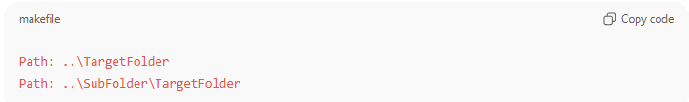
Path: Folder\..
Path: SubFolder\SubSubFolder\..
- Examples:
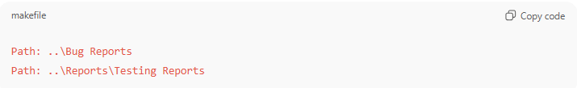
Path: ..\Bug Reports
Path: ..\Reports\Testing Reports
(Means: the target is Bug Reports or Testing Reports, ignoring what comes before them.)

3. Relative Path (Folder Reference with Ignored Depth)
# Source: AI Source: Provided by: [Data Path: Persons Table -> ID Column: 1, Name_En Column: Motasem Essam] -> From: [ChatGPT] on [7/14/2025]
- Description:

Ends with \...
This means: my target folder is inside this folder, but I don’t care how deep (directly inside, or within subfolders).
- Format:
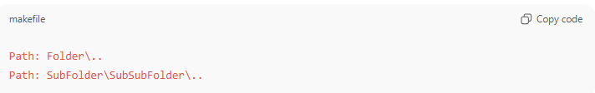
Path: Folder\..
Path: SubFolder\SubSubFolder\..
- Examples:
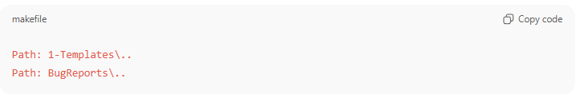
Path: 1-Templates\..
Path: BugReports\..
(Means: the target is somewhere inside 1-Templates or BugReports, ignoring the exact subfolder.)

4. Relative Path (Partial Navigation)
# Source: AI Source: Provided by: [Data Path: Persons Table -> ID Column: 1, Name_En Column: Motasem Essam] -> From: [ChatGPT] on [7/14/2025]
- Description:

Combines ..\ and \...
This means: my target folder is inside the given folder name, but I ignore both:
  - Where that folder is located in the structure (left side ignored), and
  - Where exactly inside it the target sits (right side ignored).
- Format:
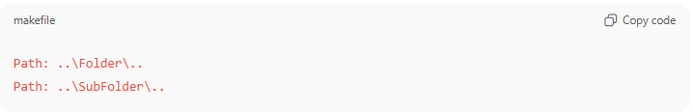
Path: ..\Folder\..
Path: ..\SubFolder\..
- Examples:
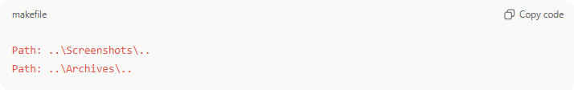
Path: ..\Screenshots\..
Path: ..\Archives\..
(Means: the target is inside Screenshots or Archives, but I don’t care where Screenshots is located, and I don’t care where exactly inside it the target is.)

5-Flexible Combined Path
# Source: AI Source: Provided by: [Data Path: Persons Table -> ID Column: 1, Name_En Column: Motasem Essam] -> From: [ChatGPT] on [7/14/2025]
- You can mix and match all four path types:
  - Absolute Path → exact location
  - Backward Reference → ..\ ignores all structure behind
  - Folder Reference with Ignored Depth → Folder\.. ignores internal depth
  - Partial Navigation → ..\Folder\.. ignores both behind and inside
- This lets you describe any folder or file location in a flexible, reusable, and standardized way.
Format:
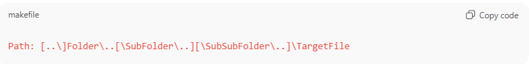
Path: [..\]Folder\..[\SubFolder\..][\SubSubFolder\..]\TargetFile
- [..\] → optional backward reference
- Folder\.. → folder reference ignoring depth
- ..\Folder\.. → partial navigation (ignore both sides)
- TargetFile → the actual file or end folder
Example Usages:
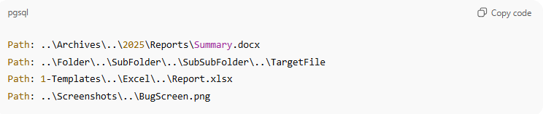
Path: ..\Archives\..\2025\Reports\Summary.docx
Path: ..\Folder\..\SubFolder\..\SubSubFolder\..\TargetFile
Path: 1-Templates\..\Excel\..\Report.xlsx
Path: ..\Screenshots\..\BugScreen.png
Meaning / Usage:
- The path can ignore folders behind, ignore internal depth, or both, depending on your needs.
- Makes templates and references flexible — works even if folder hierarchy changes.
- Can be as long or short as necessary, combining rules multiple times in the same path.

This format allows you to freely apply all four rules anywhere in the path, exactly like your example ..\Folder\..\SubFolder\..\SubSubFolder\..\TargetFile.
If you want, I can now draw a diagram showing this fully flexible path with multiple ..\ and \.. segments, so it’s visual and easy to explain.
Do you want me to do that?

3-Storage Reference

Knowledge Base

What is Storage Reference?
# Source: AI Source: Provided by: [Data Path: Persons Table -> ID Column: 1, Name_En Column: Motasem Essam] -> From: [ChatGPT] on [7/14/2025]
Storage Reference means the structured way you describe or record where file is stored —
including what type of storage it is (local, cloud, repo), where exactly it’s located, and how it’s accessed.

Rules and Guidelines

1- Storage Reference
# Source: AI Source: Provided by: [Data Path: Persons Table -> ID Column: 1, Name_En Column: Motasem Essam] -> From: [ChatGPT] on [7/14/2025]
There are three main types of Storage Format, each representing a different kind of storage environment:
- Local Storage Format — used for drives, folders, and files stored on local machines or internal network paths.
- Cloud Storage Format — used for online file hosting services such as Google Drive, OneDrive, Dropbox, or AWS S3.
- Version Control Storage Format — used for code repositories managed on platforms like GitHub, GitLab, or Bitbucket.

1-LocalStorage Format
# Source: AI Source: Provided by: [Data Path: Persons Table -> ID Column: 1, Name_En Column: Motasem Essam] -> From: [ChatGPT] on [7/14/2025]
Purpose:
Defines how to describe and record local or network-based storage drives used for saving files, folders, or project data.
Format (One Line):
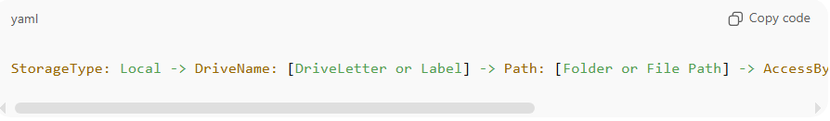
StorageType: Local -> DriveName: [DriveLetter or Label] -> Path: [Folder or File Path] -> AccessBy: [Username or Email] -> Notes: [Optional Details]
Example (One Line):
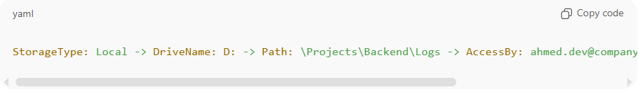
StorageType: Local -> DriveName: D: -> Path: \Projects\Backend\Logs -> AccessBy: ahmed.dev@company.com -> Notes: Log archive location

2-CloudStorage Format
# Source: AI Source: Provided by: [Data Path: Persons Table -> ID Column: 1, Name_En Column: Motasem Essam] -> From: [ChatGPT] on [7/14/2025]
Purpose:
Defines how to represent cloud-based file storage such as Google Drive, Dropbox, OneDrive, AWS S3, or similar services.
Format (One Line):
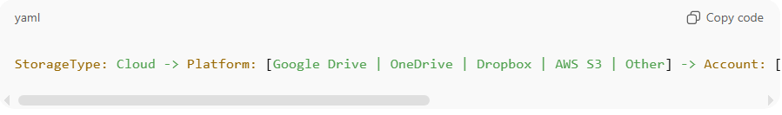
StorageType: Cloud -> Platform: [Google Drive | OneDrive | Dropbox | AWS S3 | Other] -> Account: [Username or Email] -> Path: [Folder or File Path] -> Notes: [Optional Details]
Example (One Line):
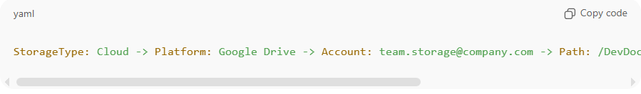
StorageType: Cloud -> Platform: Google Drive -> Account: team.storage@company.com -> Path: /DevDocs/Reports -> Notes: Shared project documentation

3-VersionControlStorage Format
# Source: AI Source: Provided by: [Data Path: Persons Table -> ID Column: 1, Name_En Column: Motasem Essam] -> From: [ChatGPT] on [7/14/2025]
Purpose:
Defines how to record code repositories hosted on version-control platforms like GitHub, GitLab, Bitbucket, or others, with the ability to reference either an entire commit or a specific file within a commit.
This allows tracking both changes at the commit level and specific file updates for better traceability.

This format allows you to link either to a commit, branch, repository, or a specific file while keeping the storage details consistent and traceable.
Note: You can indicate a specific file at three levels:
- After Commit → points to a file in a specific commit
- After Branch → points to a file in a branch (latest or target commit implied)
- After Repository → points to a file anywhere in the repository

Formats (One Line)
1. Commit-Level Reference
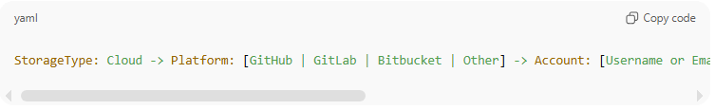
StorageType: Cloud -> Platform: [GitHub | GitLab | Bitbucket | Other] -> Account: [Username or Email] -> Repository: [RepoName] -> Branch: [BranchName] -> Commit: [CommitName or CommitHash]

2. File/Folder-Level Reference
2.1. File/Folder after Commit
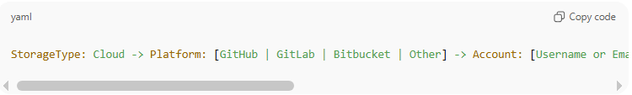
StorageType: Cloud -> Platform: [GitHub | GitLab | Bitbucket | Other] -> Account: [Username or Email] -> Repository: [RepoName] -> Branch: [BranchName] -> Commit: [CommitName or CommitHash] -> Path: [Folder or File Path]
2.2. File/Folder after Branch
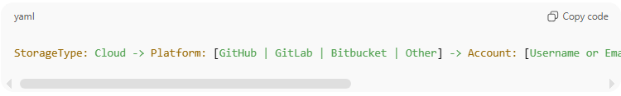
StorageType: Cloud -> Platform: [GitHub | GitLab | Bitbucket | Other] -> Account: [Username or Email] -> Repository: [RepoName] -> Branch: [BranchName] -> Path: [Folder or File Path]
2.3. File/Folder after Repository
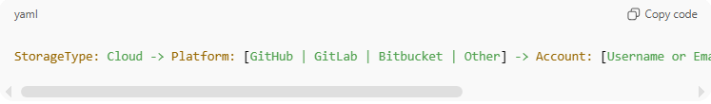
StorageType: Cloud -> Platform: [GitHub | GitLab | Bitbucket | Other] -> Account: [Username or Email] -> Repository: [RepoName] -> Path: [Folder or File Path]

Examples (One Line, Grey Background)
Commit-Level Example
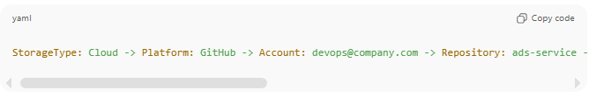
StorageType: Cloud -> Platform: GitHub -> Account: devops@company.com -> Repository: ads-service -> Branch: feature/get-approved-ads -> Commit: add-approved-ads-endpoint (hash: 5f9c8a2)

File/Folder -Level Example
1. File/Folder after Commit

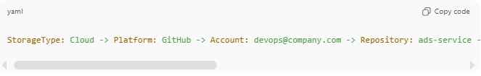
StorageType: Cloud -> Platform: GitHub -> Account: devops@company.com -> Repository: ads-service -> Branch: feature/get-approved-ads -> Commit: add-approved-ads-endpoint (hash: 5f9c8a2) -> Path: /backend/routes/ads.js
2. File after Branch
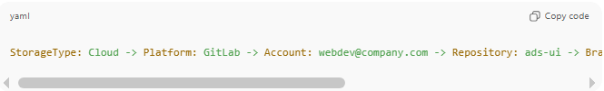
StorageType: Cloud -> Platform: GitLab -> Account: webdev@company.com -> Repository: ads-ui -> Branch: feature/approved-ads -> Path: /frontend/src/components/AdList.vue
3. File after Repository
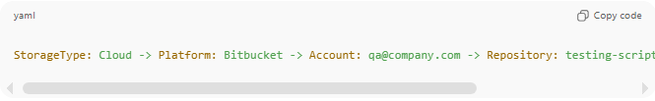
StorageType: Cloud -> Platform: Bitbucket -> Account: qa@company.com -> Repository: testing-scripts -> Path: /scripts/load_test.py

Notes:
- Use Commit-Level Reference when you want to track a whole commit (all files affected).
- Use File-Level Reference when you want to track a specific file inside a commit.
- Both formats are compatible with File Tracking Rules, so you can integrate changes for individual files or whole commits.

🧭 Integration with File Tracking
# Source: AI Source: Provided by: [Data Path: Persons Table -> ID Column: 1, Name_En Column: Motasem Essam] -> From: [ChatGPT] on [7/14/2025]
The File Tracking Rules can be linked with the VersionControlStorage Format when describing changes stored in version-control systems (like GitHub, GitLab, or Bitbucket).
Instead of repeating repository details after every file entry, you define them once, and they apply to all files affected by that commit or branch change.

🧱 Usage Format
First, specify the VersionControlStorage details, then list the file tracking actions under it.
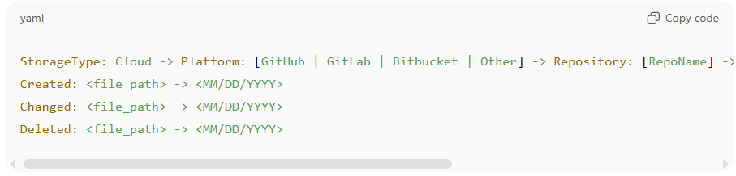
StorageType: Cloud -> Platform: [GitHub | GitLab | Bitbucket | Other] -> Repository: [RepoName] -> Branch: [BranchName] -> Commit: [CommitName or CommitHash]
Created: <file_path> -> <MM/DD/YYYY>
Changed: <file_path> -> <MM/DD/YYYY>
Deleted: <file_path> -> <MM/DD/YYYY>

🧩 Example 1 — GitHub Example
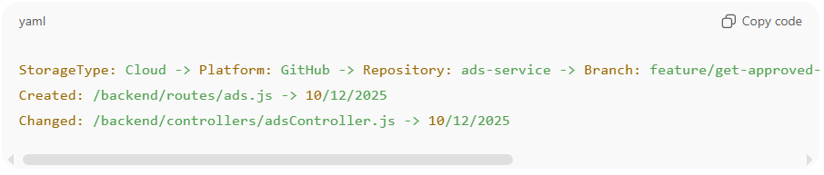
StorageType: Cloud -> Platform: GitHub -> Repository: ads-service -> Branch: feature/get-approved-ads -> Commit: add-approved-ads-endpoint (hash: 5f9c8a2)
Created: /backend/routes/ads.js -> 10/12/2025
Changed: /backend/controllers/adsController.js -> 10/12/2025

🧩 Example 2 — GitLab Example
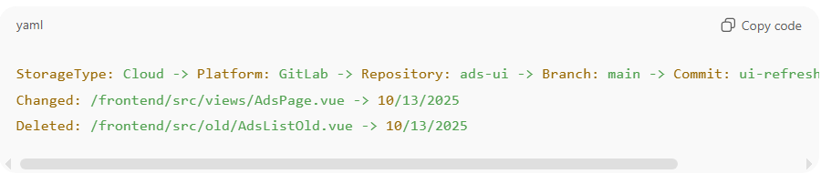
StorageType: Cloud -> Platform: GitLab -> Repository: ads-ui -> Branch: main -> Commit: ui-refresh (hash: 9b2de8c)
Changed: /frontend/src/views/AdsPage.vue -> 10/13/2025
Deleted: /frontend/src/old/AdsListOld.vue -> 10/13/2025

📘 Note
- You define one VersionControlStorage header per commit or batch of related changes.
- All file tracking entries below it inherit that same repository, branch, and commit context.
- This keeps your logs clean, organized, and consistent with Storage Template rule #6 (VersionControlStorage Format).

🧭 Integration with File/Folder Paths
# Source: AI Source: Provided by: [Data Path: Persons Table -> ID Column: 1, Name_En Column: Motasem Essam] -> From: [ChatGPT] on [7/14/2025]:
This integration ensures that every file or folder defined under Storage Format follows the flexible and standardized Path Rules described in File/Folder Paths Integration.
How It Works:
- Each stored file (in any storage type — Local, Cloud, or Hybrid) uses the Path: prefix to describe its location.
- The Path can follow any of the five supported types:
  - Absolute Path → Exact drive or root-based location
  - Relative Path (Backward Reference) → Uses ..\ to ignore parent structure
  - Relative Path (Folder Reference with Ignored Depth) → Ends with \.. to ignore subfolder depth
  - Relative Path (Partial Navigation) → Uses ..\Folder\.. to ignore both sides
  - Flexible Combined Path → Any mix of the above rules for adaptable references
- This allows Storage Formats to remain valid even if folder structures or repository branches change.
- Works for Local, Cloud, and Hybrid storage:
  - Local Storage: Uses direct or relative system paths.
  - Cloud Storage: Applies the same rules after the base repository path (e.g., Repository:\..\Reports\..\Data.xlsx).
  - Hybrid Storage: Combines both — can reference cloud repositories using relative segments.
Integration Example (One Line):
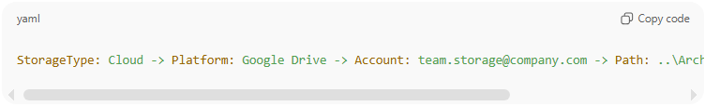
StorageType: Cloud -> Platform: Google Drive -> Account: team.storage@company.com -> Path: ..\Archives\..\2025\Reports\Summary.xlsx

Note
Path here can replace with File: [FilePath] or Folder [FolderPath]

Meaning:
The file Summary.xlsx is in the Reports folder inside 2025, located somewhere within Archives, ignoring exact depth and repository structure.
This keeps paths consistent even when repository folders or local sync structures change.

If you want, I can also create a fully combined example showing multiple files under one storage + paths integration in one grey block, so it’s ready for your documentation. Do you want me to do that?

✅ Summary Table
# Source: AI Source: Provided by: [Data Path: Persons Table -> ID Column: 1, Name_En Column: Motasem Essam] -> From: [ChatGPT] on [7/14/2025]
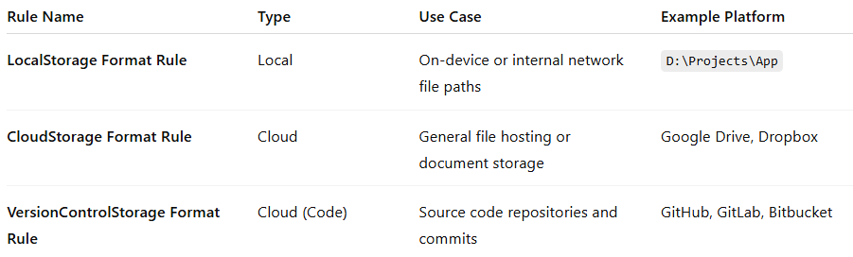
Rule Name | Type | Use Case | Example Platform
LocalStorage Format Rule | Local | On-device or internal network file paths | D:\Projects\App
CloudStorage Format Rule | Cloud | General file hosting or document storage | Google Drive, Dropbox
VersionControlStorage Format Rule | Cloud (Code) | Source code repositories and commits | GitHub, GitLab, Bitbucket

4-File Content Reference

Knowledge Base

What is File Content Reference?
# Source: AI Source: Provided by: [Data Path: Persons Table -> ID Column: 1, Name_En Column: Motasem Essam] -> From: [ChatGPT] on [7/14/2025]
A File Content Reference is a standardized way to point to a specific location, section, or content inside a file, rather than just referencing the file itself. It allows precise tracking, documentation, and collaboration by indicating exactly where in a file the relevant information resides.

Purpose:
Defines how to indicate specific content inside any file type — text, code, images, video, or audio.
Allows precise references for documentation, review, and collaboration, and works alongside Storage Format and File Tracking rules.

Rules and Guidelines

1-File Content Reference
# Source: AI Source: Provided by: [Data Path: Persons Table -> ID Column: 1, Name_En Column: Motasem Essam] -> From: [ChatGPT] on [7/14/2025]
Usage Rules / Notes:
- Text / Code Files
  - Lines: start-end → specific lines
  - Section: SectionName or heading → logical section, function, or document heading
  - MediaType: Text | Image | Video → indicates the type of content you want to reference within the file
  - Pattern: keyword/regex → search pattern or string
  - Keyword: optional text to indicate what to reference inside lines/section
  - Positioning keywords: at, before, after → indicate where the content is relative to the Keyword
    - at → content is exactly the Keyword
    - before → content is before the Keyword
    - after → content is after the Keyword
- Images:
  - Origin is the top-left corner by default (x=0, y=0).
  - Region: x,y,width,height → pixel or relative coordinates
  - Can use keywords for position: e.g., center, top-left, left of apple, right of tree.
  - Optional annotation or label
- Video / Audio:
  - Time: start-end → HH:MM:SS or seconds
  - Time: start → indicates start time only; end time is optional.
  - Optional Frame: number
  - Optional caption or scene description
- Can combine multiple indicators in a single line.
- Works for Local, Cloud, or VersionControlStorage.
- Integrates with File Tracking — can track both file and content-level changes.

Format (One Line)
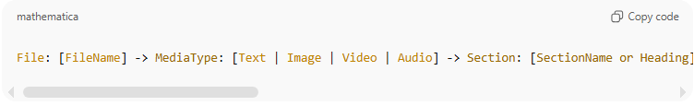
File: [FileName] -> MediaType: [Text | Image | Video | Audio] -> Section: [SectionName or Heading] -> Keyword: [Keyword] -> Position: [before | after | at] -> Pattern: [Pattern] -> Time: [start-end] -> Frame: [number] -> Region: [x,y,width,height] -> Notes: [Description]

Field explanations:
- File: Name of the file.
- MediaType: Type of content inside the file (Text, Image, Video, Audio).
- Section: Section name, function name, or document heading (Text/Code only).
- Keyword: Optional text to indicate the specific content.
- Position: Only for Text or Image, relative to Keyword:
  - at → content is exactly the Keyword
  - before → content is before the Keyword
  - after → content is after the Keyword
- Pattern: Search string or regex (Text only).
- Time: Start-end time (Video/Audio only).
- Frame: Frame number (Video/Image only).
- Region: Coordinates (x,y,width,height) for Image/Video.
- Notes: Any additional description.

Examples (One Line, Grey Background)
1. Text / Code File
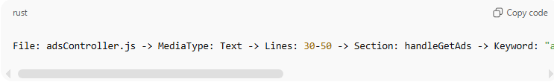
File: adsController.js -> MediaType: Text -> Lines: 30-50 -> Section: handleGetAds -> Keyword: "approvedAds" -> Position: at -> Pattern: "approvedAds" -> Notes: Logic for approved ads filtering
2. Image
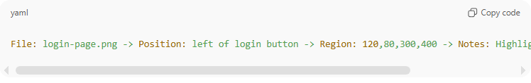
File: login-page.png -> Position: left of login button -> Region: 120,80,300,400 -> Notes: Highlighted login form elements
3. Video
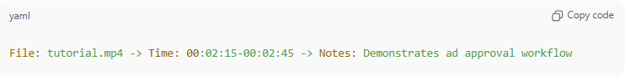
File: tutorial.mp4 -> Time: 00:02:15-00:02:45 -> Notes: Demonstrates ad approval workflow
4. Audio
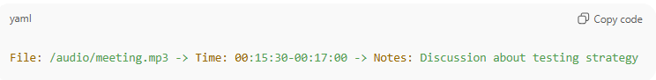
File: /audio/meeting.mp3 -> Time: 00:15:30-00:17:00 -> Notes: Discussion about testing strategy
5. Combined Example
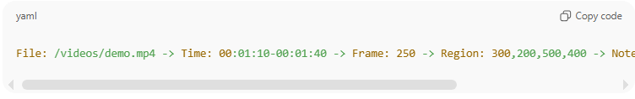
File: /videos/demo.mp4 -> Time: 00:01:10-00:01:40 -> Frame: 250 -> Region: 300,200,500,400 -> Notes: Focus on approved ads animation

🧭 Integration with Storage Reference
# Source: AI Source: Provided by: [Data Path: Persons Table -> ID Column: 1, Name_En Column: Motasem Essam] -> From: [ChatGPT] on [7/14/2025]
Purpose:
This integration ensures that all files and folders stored under Storage Format can be precisely referenced and annotated. It combines:
- Storage Type Reference — Local, Cloud, or VersionControlStorage
- File Content Reference — Exact lines, sections, patterns, time, frames, or regions
This provides a full traceable workflow from storage location to file content.

Usage Rules / Notes:
- Applicable Storage Types:
  - Can be used with any type of Storage Format: Local, Cloud, VersionControlStorage.
- VersionControlStorage Constraints:
  - Can be used only in File-Level Reference (Repository → Branch → File → optional content).
  - Cannot be used at Commit-Level Reference alone for content tracking.
- File Content Reference Integration:
  - Text / Code: Lines, Sections, Patterns
  - Images: Regions, Coordinates, or Keywords (e.g., center, left of apple)
  - Video: Start Time only, optional Frame
  - Audio: Time range
  - Supports combining multiple indicators in one line.

Format Example (One Line, Grey Background)
Text/Code in VersionControlStorage (File-Level Reference)
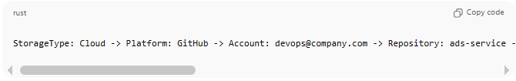
StorageType: Cloud -> Platform: GitHub -> Account: devops@company.com -> Repository: ads-service -> Branch: feature/get-approved-ads -> File: adsController.js -> Lines: 30-50 -> Section: handleGetAds -> Pattern: "approvedAds" -> Notes: Logic for approved ads filtering

Image in Cloud Storage
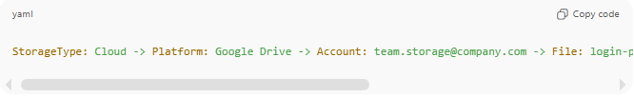
StorageType: Cloud -> Platform: Google Drive -> Account: team.storage@company.com -> File: login-page.png -> Region: center -> Notes: Highlighted login form elements
Video in Cloud Storage
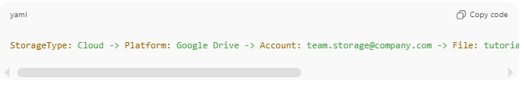
StorageType: Cloud -> Platform: Google Drive -> Account: team.storage@company.com -> File: tutorial.mp4 -> Time: 00:02:15 -> Notes: Start of ad approval demonstration

Integration Notes:
- Works for all Storage Formats: Local, Cloud, VersionControlStorage.
- In VersionControlStorage, File-Level Reference allows precise content tracking inside a repository.
- Commit-Level Reference cannot be used alone to track file content; you must reference a File.
- Combines Storage Reference + File Content Reference for full traceability across all file types.

5- File Tracking

Knowledge Base

What is File Tracking?
# Source: AI Source: Provided by: [Data Path: Persons Table -> ID Column: 1, Name_En Column: Motasem Essam] -> From: [ChatGPT] on [7/14/2025]
File Tracking is a method of keeping a record of important information about files, so you always know when they were created, modified, or deleted. It helps in understanding the history, changes, and evolution of files over time.
This is useful in many contexts, such as:
- Personal or work documents (tracking edits or versions of reports, spreadsheets, etc.)
- Digital archives (knowing when files were added or updated)
- Software development (tracking code changes)
- Any situation where file history matters

Rules and Guidelines

1-File Tracking
# Source: AI Source: Provided by: [Data Path: Persons Table -> ID Column: 1, Name_En Column: Motasem Essam] -> From: [ChatGPT] on [7/14/2025]
File Tracking Rules
- Created
  - Use this tag when a file is first added.
  - Format:
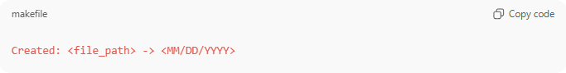
Created: <file_path> -> <MM/DD/YYYY>
  - Example:
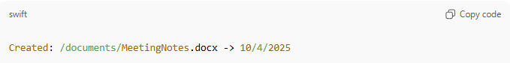
Created: /documents/MeetingNotes.docx -> 10/4/2025
- Changed
  - Use this tag whenever a file is modified.
  - Format:
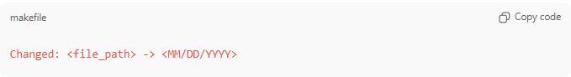
Changed: <file_path> -> <MM/DD/YYYY>
  - Example:
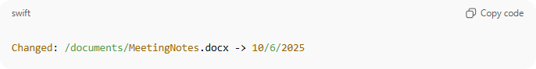
Changed: /documents/MeetingNotes.docx -> 10/6/2025
- Deleted
  - Use this tag when a file is permanently removed.
  - Format:
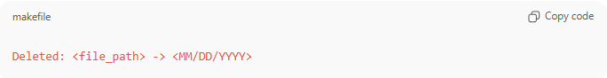
Deleted: <file_path> -> <MM/DD/YYYY>
  - Example:
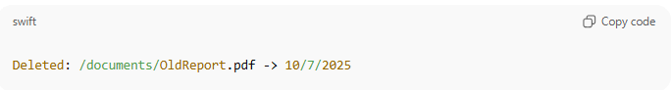
Deleted: /documents/OldReport.pdf -> 10/7/2025
- Notes / Best Practices
  - Keep the most recent change date for files that are modified multiple times.
  - Maintain a central log (like FILES_LOG.md) or at the top of files for easy reference.
  - Optionally, include a short description of the change.

Example FILES_LOG.md
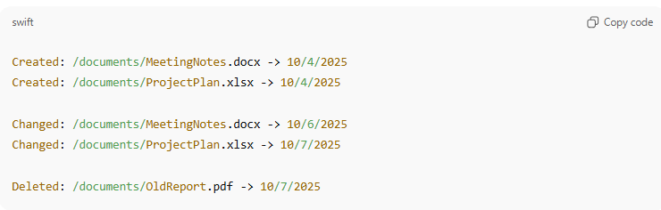
Created: /documents/MeetingNotes.docx -> 10/4/2025
Created: /documents/ProjectPlan.xlsx -> 10/4/2025

Changed: /documents/MeetingNotes.docx -> 10/6/2025
Changed: /documents/ProjectPlan.xlsx -> 10/7/2025

Deleted: /documents/OldReport.pdf -> 10/7/2025

6-Transfer Metadata

Knowledge Base

what is Transfer Metadata
# Source: AI Source: Provided by: [Data Path: Persons Table -> ID Column: 1, Name_En Column: Motasem Essam] -> From: [ChatGPT] on [7/14/2025]
Transfer Metadata simply means the descriptive information you record about a transfer when you move or copy files/folders.

Rules and Guidelines

1-Transfer Metadata
# Source: AI Source: Provided by: [Data Path: Persons Table -> ID Column: 1, Name_En Column: Motasem Essam] -> From: [ChatGPT] on [7/14/2025]
  - every time you transfer a file or folder. Basically, for each transfer, you need to record these metadata:
- Name → file or folder name
- Size → size of the file/folder at time of transfer
- Transfer Date → the date when you did the transfer (time is optional)
- Source → where the file/folder was copied or transferred from (e.g., Main, GitHub, Google Drive, Mega Drive, Flash)
- Link/Path (Optional) → URL or local storage path of the transferred item
  - A transfer record can include metadata about more than one entity (file or folder).
So the record format (your rule) could look like this

Rule Formats
Format 1: Standard Transfer Metadata
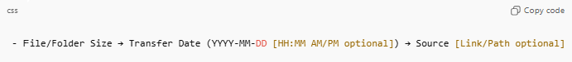
- File/Folder Name [type] → File/Folder Size → Transfer Date (YYYY-MM-DD [HH:MM AM/PM optional]) → Source [Link/Path optional]

Format 2: Transfer Metadata with Multiple Entities (Optional)
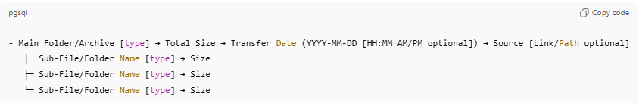
- Main Folder/Archive [type] → Total Size → Transfer Date (YYYY-MM-DD [HH:MM AM/PM optional]) → Source
├─ Sub-File/Folder Name [type] → Size
├─ Sub-File/Folder Name [type] → Size
└─ Sub-File/Folder Name [type] → Size

Examples
Example 1: Standard Transfer Metadata
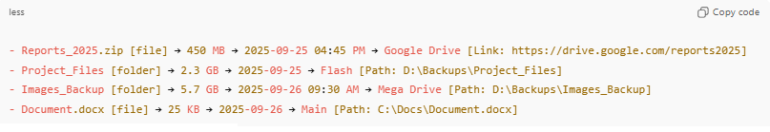
- Reports_2025.zip [file] → 450 MB → 2025-09-25 04:45 PM → Google Drive [Link: https://drive.google.com/reports2025]
- Project_Files [folder] → 2.3 GB → 2025-09-25 → Flash [Path: D:\Backups\Project_Files]
- Images_Backup [folder] → 5.7 GB → 2025-09-26 09:30 AM → Mega Drive [Path: D:\Backups\Images_Backup]
- Document.docx [file] → 25 KB → 2025-09-26 → Main [Path: C:\Docs\Document.docx]

Example 2: Transfer Metadata with Multiple Entities
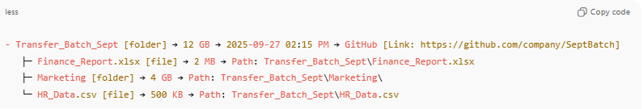
- Transfer_Batch_Sept [folder] → 12 GB → 2025-09-27 02:15 PM → GitHub [Link: https://github.com/company/SeptBatch]
├─ Finance_Report.xlsx [file] → 2 MB → Path: Transfer_Batch_Sept\Finance_Report.xlsx
├─ Marketing [folder] → 4 GB → Path: Transfer_Batch_Sept\Marketing\
└─ HR_Data.csv [file] → 500 KB → Path: Transfer_Batch_Sept\HR_Data.csv

7-File Collection

Knowledge Base

What is File Collection?
# Source: AI Source: Provided by: [Data Path: Persons Table -> ID Column: 1, Name_En Column: Motasem Essam] -> From: [ChatGPT] on [7/14/2025]
A File Collection is a structured record file that represents the complete organized contents of a folder (and its subfolders), with optional links to database entries.
It’s not just a list of files — it’s a documentation snapshot that captures:
- The hierarchy of folders (with numbered headings and subheadings),
- The files inside each folder (with bullet numbers and optional database IDs),
- The progress tracking (Last ID recorded) showing which database entries have already been documented.

🧩 In Other Words
A Collection is like a map + logbook of a folder’s contents.
It connects three layers of information:
- Physical structure → what’s in the folder and subfolders.
- Logical structure → how those items are organized and related (via numbering and hierarchy).
- Database link → which of those items correspond to stored records in your system.

💡 So, Definition (based on your rules)
Collection:
A “Collection” is a structured documentation file named after a specific folder (e.g., Sources Collections), containing a hierarchical list of all subfolders and files.
Each entry can reference a corresponding record ID from a database, and the file tracks the latest recorded ID to mark documentation progress.

Rules and Guidelines

1- File Collection

1-File Naming
# Source: AI Source: Provided by: [Data Path: Persons Table -> ID Column: 1, Name_En Column: Motasem Essam] -> From: [ChatGPT] on [7/14/2025]
Each generated file that lists all folders and files must be named:

<FolderName> Collections
Examples:
- Information Collections
- Links Collections
- Sources Collections

2-Main File Heading
# Source: AI Source: Provided by: [Data Path: Persons Table -> ID Column: 1, Name_En Column: Motasem Essam] -> From: [ChatGPT] on [7/14/2025]
At the top of each Collections file, include:
- The file name as the main heading.
- The Data Path (showing the related database structure).
- The Last ID recorded (for tracking your latest entry).
Example:
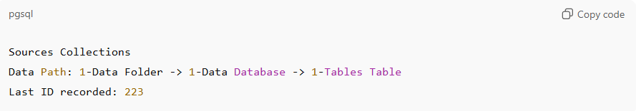
Sources Collections
Data Path: 1-Data Folder -> 1-Data Database -> 1-Tables Table
Last ID recorded: 223
Formatting Rules:
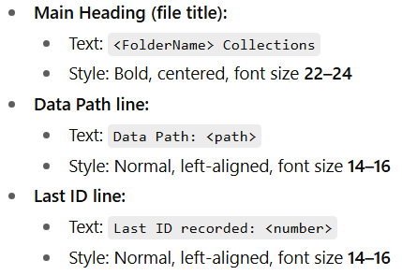
- Main Heading (file title):
  - Text: <FolderName> Collections
  - Style: Bold, centered, font size 22–24
- Data Path line:
  - Text: Data Path: <path>
  - Style: Normal, left-aligned, font size 14–16
- Last ID line:
  - Text: Last ID recorded: <number>
  - Style: Normal, left-aligned, font size 14–16
Purpose:
- The main heading identifies the collection file.
- The data path shows exactly where the related database or table exists.
- The Last ID recorded marks your progress — so you can continue adding from the next record.

3-Folder & Subfolder Headings
# Source: AI Source: Provided by: [Data Path: Persons Table -> ID Column: 1, Name_En Column: Motasem Essam] -> From: [ChatGPT] on [7/14/2025]
Inside each file, show every folder and subfolder as a clear, formatted heading that mirrors the directory structure.
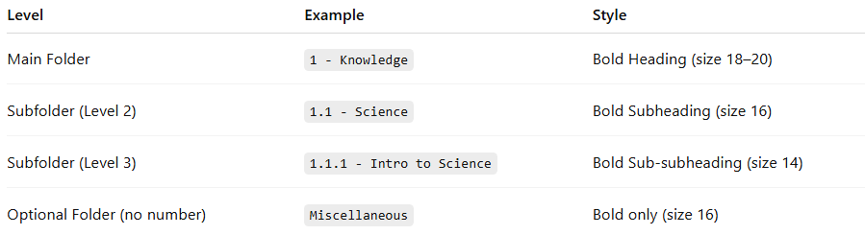
Level | Example | Style
Main Folder | 1 - Knowledge | Bold Heading (size 18–20)
Subfolder (Level 2) | 1.1 - Science | Bold Subheading (size 16)
Subfolder (Level 3) | 1.1.1 - Intro to Science | Bold Sub-subheading (size 14)
Optional Folder (no number) | Miscellaneous | Bold only (size 16)
Numbering Rules:
- Hierarchical format: 1, 1.1, 1.1.1, 2, etc.
- Reset numbering when returning to a higher level.
- Optional folders (non-numbered) just use bold text (size 16).
- Use indentation to reflect folder depth visually.

4-File Listings
# Source: AI Source: Provided by: [Data Path: Persons Table -> ID Column: 1, Name_En Column: Motasem Essam] -> From: [ChatGPT] on [7/14/2025]
Under each folder or subfolder heading, list the files it contains with numbered bullets and their corresponding database record IDs (if any).
Example:
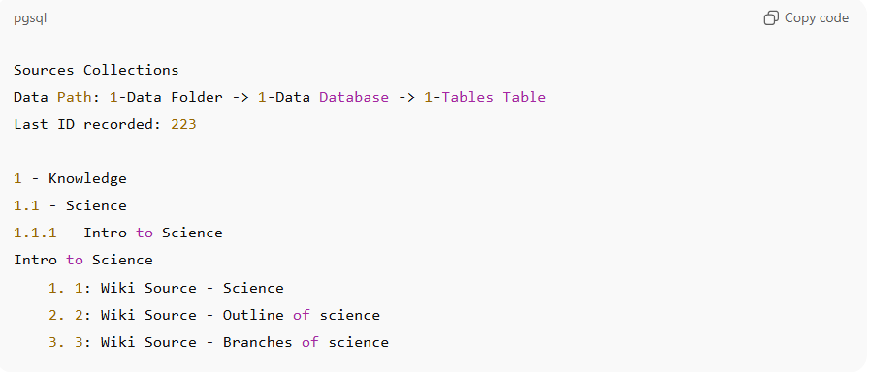
Sources Collections
Data Path: 1-Data Folder -> 1-Data Database -> 1-Tables Table
Last ID recorded: 223

1 - Knowledge
1.1 - Science
1.1.1 - Intro to Science
Intro to Science
1. 1: Wiki Source - Science
2. 2: Wiki Source - Outline of science
3. 3: Wiki Source - Branches of science
File Entry Structure:
- First number (1., 2., 3.) → bullet order
- Number before colon (1:, 2:, 3:) → database record ID
- Text after colon → file name or description
- Indentation → shows folder depth

5-Database Table Integration
# Source: AI Source: Provided by: [Data Path: Persons Table -> ID Column: 1, Name_En Column: Motasem Essam] -> From: [ChatGPT] on [7/14/2025]
When the collection corresponds to a database table:
- Add at the top of the file:
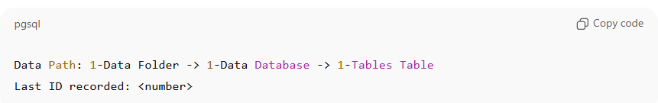
Data Path: 1-Data Folder -> 1-Data Database -> 1-Tables Table
Last ID recorded: <number>
✅ This identifies the source table and your progress.
- In file listings, show the record ID for each entry:
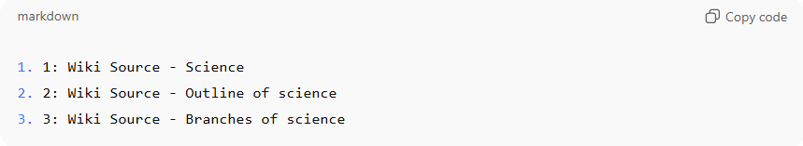
1. 1: Wiki Source - Science
2. 2: Wiki Source - Outline of science
3. 3: Wiki Source - Branches of science
Notes:
- The number before the colon matches the record ID in the related database table.
- If no database applies, use:
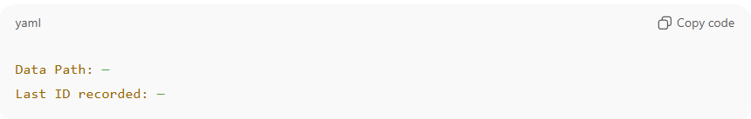
Data Path: —
Last ID recorded: —

8-File header metadata

Knowledge Base

What is File header metadata?
# Source: AI Source: Provided by: [Data Path: Persons Table -> ID Column: 1, Name_En Column: Motasem Essam] -> From: [ChatGPT] on [12/21/2025]
File header metadata is the information stored at the beginning (header) of a file that describes how the rest of the file is structured and how it should be interpreted.
Think of it as the file’s ID card 📄—it tells software what the file is, how to read it, and what to expect inside.

Rules and Guidelines

1- File header metadata
# Source: AI Source: Provided by: [Data Path: Persons Table -> ID Column: 1, Name_En Column: Motasem Essam] -> From: [ChatGPT] on [12/21/2025]
- File header metadata can be added either at the top of the file or maintained in a separate file.
- Optional: File header metadata is not mandatory and may be included or omitted. If included, it may appear at the top of the file or in a separate metadata file.
- What File Header Metadata Typically Contains
•* File type
•* Version number
•* File size
* created_at
* updated_at

9-FileHistory

Knowledge Base

What is FileHistory?
# Source: AI Source: Provided by: [Data Path: Persons Table -> ID Column: 1, Name_En Column: Motasem Essam] -> From: [ChatGPT] on [12/21/2025]
FileHistory is a dedicated location (or virtual folder in a database) that stores the versioned history of files. Its purpose is to track changes, edits, and metadata for files over time, allowing you to:
• See previous versions of a file.
• Track who modified what and when.
• Maintain audit trails for documentation and compliance.
• Support recovery or rollback if needed.
Think of FileHistory as a “version control area” inside your content storage.

Rules and Guidelines

1- FileHistory folder
# Source: AI Source: Provided by: [Data Path: Persons Table -> ID Column: 1, Name_En Column: Motasem Essam] -> From: [ChatGPT] on [12/21/2025]
In your StorageDrives / Content Storage blueprint:
- Each main content folder (like 6-Content Storage) contains files.
- For each file, there’s a FileHistory folder that stores:
  - Old versions (old_value)
  - Heading hierarchy changes
- Essentially, it’s a subfolder dedicated to versioning and tracking changes for files in that parent folder.

10-Sample

Knowledge Base

What is Sample?
# Source: AI Source: Provided by: [Data Path: Persons Table -> ID Column: 1, Name_En Column: Motasem Essam] -> From: [ChatGPT] on [12/23/2025]
Sample refers to an individual item or document used primarily for testing, experimentation, or demonstration purposes. It is not part of the original production data but serves as a safe copy or stand-in, allowing developers, testers, or users to explore, experiment, or validate functionality without affecting real data.

Rules and Guidelines

1-Samples Folder
# Source: AI Source: Provided by: [Data Path: Persons Table -> ID Column: 1, Name_En Column: Motasem Essam] -> From: [ChatGPT] on [12/23/2025]
The Samples Folder section contains copies of original files used for testing, experimentation, and demonstration purposes. These files allow users to safely explore StorageDrives blueprint functionalities without affecting production data.

Note: These are copies of the original files and are intended only for testing, learning, and experimentation.
Contents include:
- Documents: Sample text, spreadsheets, or PDFs used in workflow tests.
- Images: Test images for performance and format handling.
- Data Files: Experimental datasets, logs, or placeholder files.
- Rules Samples: A dedicated folder containing example rules, configurations, or scripts used to test automation, validation, and system behavior.
Usage:
- Experiment with file storage, retrieval, and processing
- Test how the system handles different file types, sizes, and formats
- Understand and validate blueprint functionalities in a safe environment

Rule for Post-Testing Handling:
# Source: AI Source: Provided by: [Data Path: Persons Table -> ID Column: 1, Name_En Column: Motasem Essam] -> From: [ChatGPT] on [12/23/2025]
- Once testing or experimentation is completed, the root cause for using these sample files should be reviewed.
- Based on this review, sample files must either be:
  - Deleted to free storage and prevent clutter, or
  - Archived for future reference or audit purposes.
This ensures that the environment stays clean and maintains only necessary files, while retaining a record of tests if needed.

File Versioning Rules
# Source: AI Source: Provided by: [Data Path: Persons Table -> ID Column: 1, Name_En Column: Motasem Essam] -> From: [ChatGPT] on [12/23/2025]
Version Definitions
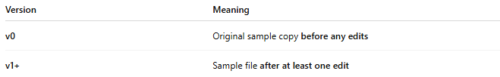
Version | Meaning
v0 | Original sample copy before any edits
v1+ | Sample file after at least one edit

Versioning Guidelines
- v0 (Baseline Version)
  - Represents the initial sample file
  - No modifications allowed
  - Must remain unchanged as a reference point
- v1, v2, v3, … (Edited Versions)
  - Created after any edit, including:
    - Content changes
    - Formatting changes
    - Rule or configuration updates
  - Each edit must increment the version number
- Version Naming Convention (Recommended)
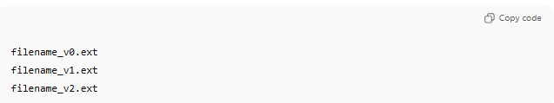
- Do Not Overwrite
  - Never overwrite a previous version
  - Always create a new version when editing

VERSIONS.md
Purpose of VERSIONS.md
- Track v0 (baseline) and all edited versions
- Clearly explain what changed, why, and when
- Preserve traceability without overwriting files
- Act as the audit record for sample evolution

VERSIONS.md — Standard Format (Template)
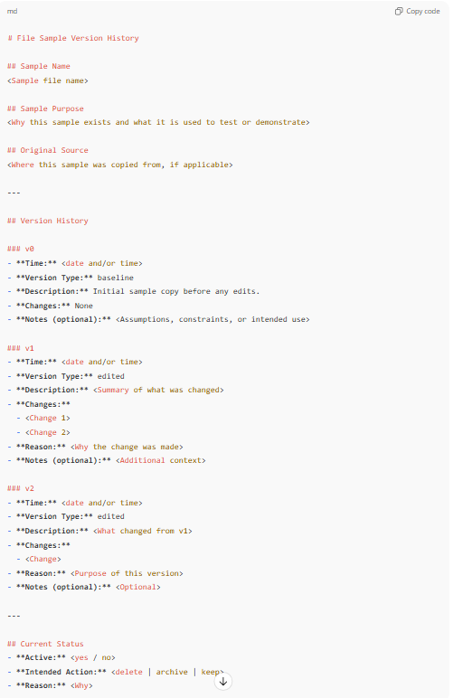
# File Sample Version History

## Sample Name
<Sample file name>

## Sample Purpose
<Why this sample exists and what it is used to test or demonstrate>

## Original Source
<Where this sample was copied from, if applicable>

---

## Version History

### v0
- **Time:** <date and/or time>
- **Version Type:** baseline
- **Description:** Initial sample copy before any edits.
- **Changes:** None
- **Notes (optional):** <Assumptions, constraints, or intended use>

### v1
- **Time:** <date and/or time>
- **Version Type:** edited
- **Description:** <Summary of what was changed>
- **Changes:**
- <Change 1>
- <Change 2>
- **Reason:** <Why the change was made>
- **Notes (optional):** <Additional context>

### v2
- **Time:** <date and/or time>
- **Version Type:** edited
- **Description:** <What changed from v1>
- **Changes:**
- <Change>
- **Reason:** <Purpose of this version>
- **Notes (optional):** <Optional>

---

## Current Status
- **Active:** <yes / no>
- **Intended Action:** <delete | archive | keep>
- **Reason:** <Why>

VERSIONS.md — Example (Sample Files)
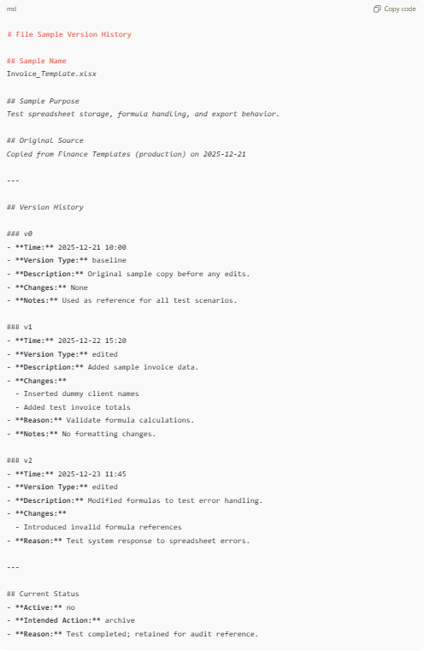
# File Sample Version History

## Sample Name
Invoice_Template.xlsx

## Sample Purpose
Test spreadsheet storage, formula handling, and export behavior.

## Original Source
Copied from Finance Templates (production) on 2025-12-21

---

## Version History

### v0
- **Time:** 2025-12-21 10:00
- **Version Type:** baseline
- **Description:** Original sample copy before any edits.
- **Changes:** None
- **Notes:** Used as reference for all test scenarios.

### v1
- **Time:** 2025-12-22 15:20
- **Version Type:** edited
- **Description:** Added sample invoice data.
- **Changes:**
- Inserted dummy client names
- Added test invoice totals
- **Reason:** Validate formula calculations.
- **Notes:** No formatting changes.

### v2
- **Time:** 2025-12-23 11:45
- **Version Type:** edited
- **Description:** Modified formulas to test error handling.
- **Changes:**
- Introduced invalid formula references
- **Reason:** Test system response to spreadsheet errors.

---

## Current Status
- **Active:** no
- **Intended Action:** archive
- **Reason:** Test completed; retained for audit reference.

11-Archive

Knowledge Base

What is Archive?
# Source: AI Source: Provided by: [Data Path: Persons Table -> ID Column: 1, Name_En Column: Motasem Essam] -> From: [ChatGPT] on [12/23/2025]
An archive is a storage location or system where files, data, or records are kept for long-term retention rather than active use. Archiving is different from just storing files in your working folders: the goal is to preserve information for future reference, compliance, or historical purposes, without cluttering active workspaces.
Here’s a breakdown:
- Purpose:
  - Keep important data safely for the long term.
  - Retain test results, experimental files, or historical records.
  - Support audits, reviews, or analysis at a later time.
- Characteristics:
  - Archived files are usually not actively modified.
  - They may be compressed or organized in a special folder or system.
  - They are easily retrievable when needed but separate from daily operations.
- Example:
  - After testing with Files Samples, you can move them to an Archive folder so they don’t clutter your workspace but are still available if you need to review past experiments.
In short, archiving is like putting files in a “safe storage room” instead of throwing them away.

Rules and Guidelines

1- Archive Folder

Archive Folder Rules
# Source: AI Source: Provided by: [Data Path: Persons Table -> ID Column: 1, Name_En Column: Motasem Essam] -> From: [ChatGPT] on [12/23/2025]
The Archive Folder is used to store sample files, test data, and other experimental files that are no longer actively used but may be needed for future reference, audit, or analysis. The following rules govern its use:
1. Eligibility for Archiving
- Only files that have completed testing or experimentation may be archived.
- Files must be reviewed to ensure they are no longer needed for active work.
- Files containing sensitive or critical data must comply with organizational data retention policies before archiving.
2. Organization
- Archive files should be organized by type, categories, Date project, or test cycle (e.g., Documents, Images, Data Files, Rules).
- Include metadata or notes indicating the test purpose, date, and any relevant context.
3. Access Control
- Archived files should have restricted editing permissions.
- Users should be able to read and retrieve archived files but not modify them.
4. Retention and Review
- Archived files must be reviewed periodically to determine whether they can be permanently deleted.
- Set a retention period (e.g., 6 months, 1 year) based on organizational policy or project needs.
5. Deletion Policy
- If archived files are no longer needed after the retention period, they should be safely deleted.
- Ensure deletion is logged or tracked to maintain accountability.
6. Rule Enforcement
- Files in the Files Samples or Rules folders must follow the rule:
  - If testing is completed: files must either be archived or deleted.
- Archiving is the preferred option if there’s potential future value or audit requirement.
Summary: The Archive Folder ensures that experimental and test files are preserved safely while keeping active storage clean and organized.

